TPC1

The markov chain is specified as a pair (X,P), where

X = {0,1,2,3,4,5,6,7,8,9}

with the correspondence: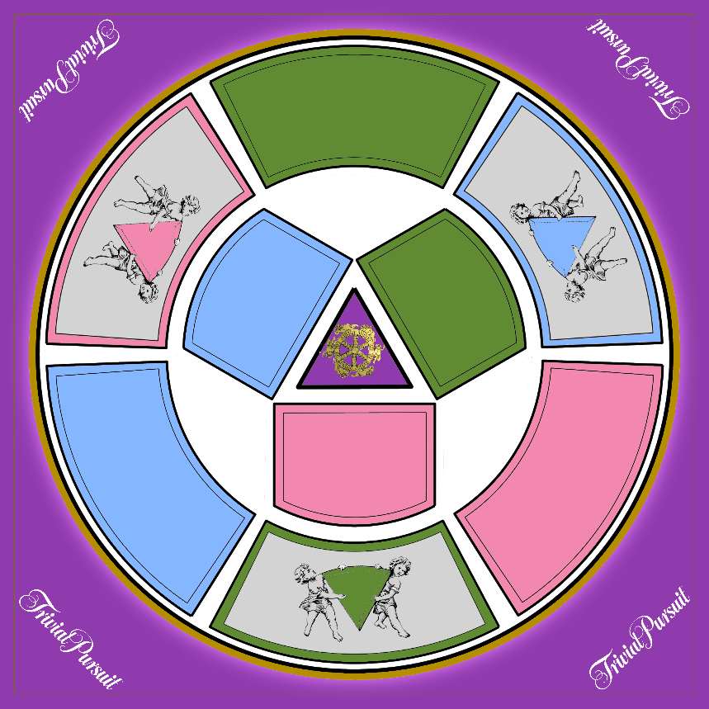

0

1

2

3

4

5

6

7

8

9

1. Probability matrix which the dice shows “1”:

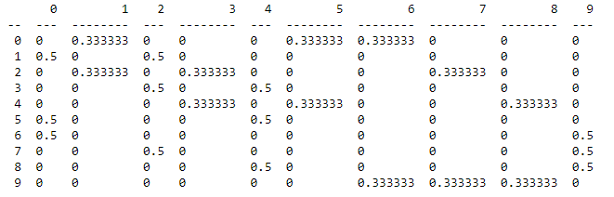

Assumig the previous matrix is called “A” , this matrix was computed by the formula A + A^2 + A^3 + A^4 + A^5 + A^6, that consider all the possible number of the dice.

Probability matrix which the dice can show all the numbers from 1 to 6:

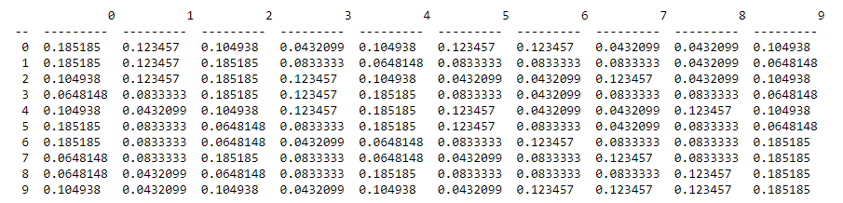

1. From the previous matrix we just compute the probability at t=3 applying the power 3:

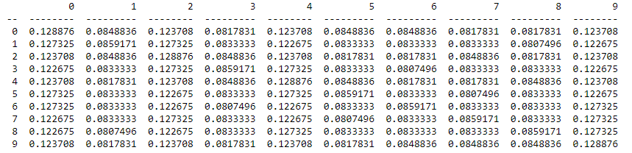

Grupo nº 37

João Silvestre, nº 80996

João Pestana, nº 79515